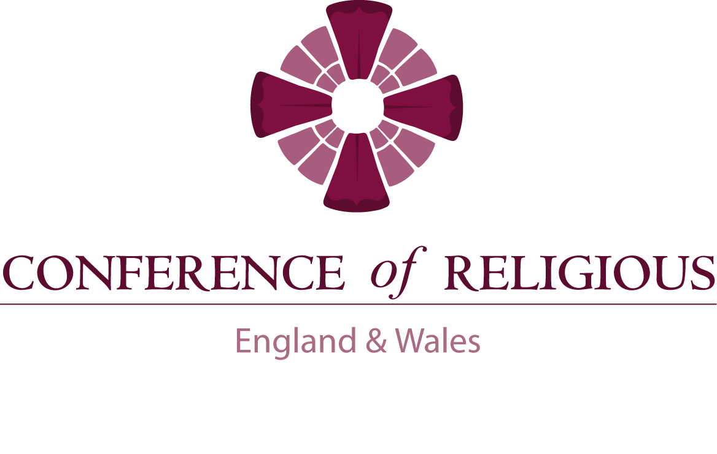

**ANNUAL REPORT 2015**

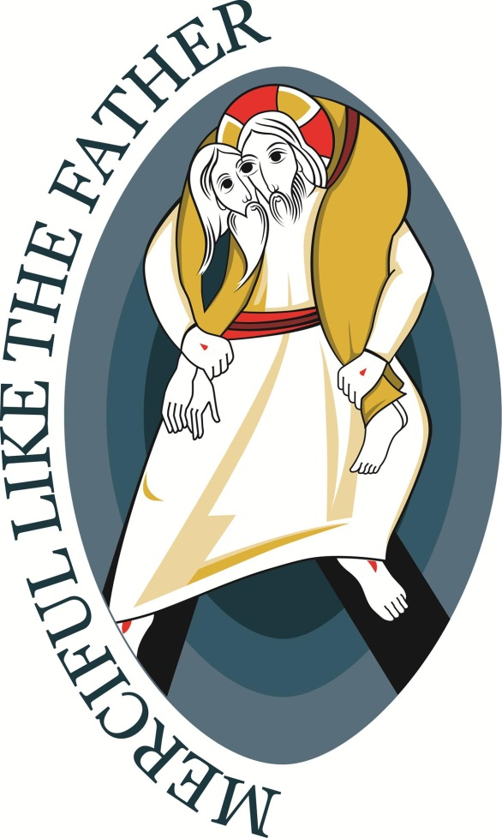

**CONTENTS**

**Executive and Secretariat 3**

**COR Mission 4**

**Letter from the President 5**

**General Secretary’s Introduction 5**

**Mixed Commission 6**

**UK Visas & Immigration / The Home Office 7**

**Vocations Promotion 8 - 9**

**Healthcare Committee 9**

**Religious Life Institute 10 - 11**

**Safeguarding 12**

**Medaille Trust 13 - 15**

**Caritas Social Action Network (CSAN) 16**

**Catholic Association for Racial Justice (CARJ) 17**

**JPIC Links 18 - 19**

**CAFOD 20 - 23**

**Housing Justice 24 - 25**

**Report on Trafficking in Europe 26**

**Catholic Missionary Union of England and Wales (CMU) 27**

**Association of British Contemplatives (ABC) 27**

**Conference of Religious of Ireland (CORI) 28**

**Conference of Religious of Scotland (CRS) 29**

**International Union of Superiors General (UISG) 30 - 31**

**Association of Provincial Bursars 31**

**Association of Senior Religious (ASR) 32**

**Conference of Leaders of Anglican Religious Communities (CLARC) 33**

**Union of the European Conferences of Major Superiors (UCESM) 34**

**Sisters Mission Committee (SMC) 35**

**EXECUTIVE MEMBERS**

**PRESIDENT: Father Martin Coyle SDB**

**VICE PRESIDENT: Sister Mary Rose Fitzsimmons HHS**

**Sister Jane Bertelsen FMDM**

**Sister Kitty Ellard IJS**

**Br Laurence Hughes FSC**

**Brother Patrick Lonsdale OFM**

**Father Terence Madden M. Afr**

**Sister Maureen Murphy FMSJ**

**Sister Frances Orchard CJ**

**Father Martin Shipperlee OSB**

**Father Richard Yeo OSB (Resigned May 2015)**

**Mother Rita-Elizabeth Woolston SS.B, Associate Member**

**Anglican Representative**

**SECRETARIAT STAFF**

**Br James Boner OFM Cap – General Secretary**

**Tel: 020 8566 7009**

[**gensec@corew.org**](mailto:gensec@corew.org)

**Ray Wilson – Administrator/Technical Manager**

**Tel: 020 8566 7025**

[**adviser@corew.org**](mailto:adviser@corew.org)

**Catherine Langridge – Administrative Secretary**

**Tel: 020 3255 1085**

[**admin@corew.org**](mailto:admin@corew.org)

**THE CONFERENCE OF RELIGIOUS IN ENGLAND AND WALES CYNHADLEDD CREFYDDWYR LLOEGR A CHYMRU**

**Our Mission**

The Conference of Religious seeks to be a dynamic and proactive presence of Church, particularly with those on the margins of society.

It aims:

* To unite its membership in collaborative initiatives translating gospel vision into reality
* To offer support to those in positions of leadership.

**Our Purpose**

The purpose of the Conference of Religious in England and Wales is to represent the leaders of religious life.

This representation happens in two main ways:

1. **Supporting our Leaders**

We encourage collaboration among leaders on major issues facing religious today and promote programmes for future formation.

2. **Speaking to Society**

We aim to address current issues from a Catholic perspective, acting as a prophetic voice on behalf of religious.

**Our Members**

The Conference of Religious in England and Wales exists for the benefit of all religious in these countries. Its formal membership however is limited to the Major Superiors of each institute or in the case of his/her temporary absence, to an officially appointed delegate.

**Letter from the President**

Dear Leaders / Members

I am delighted to introduce the Conference of Religious 2016 Annual Report which highlights some of the activity of the Executive, General Secretary, Secretariat and Members as we all try to implement and develop the various strands of the COR Strategic Plan. It also shows the many groups associated with and supported by the Conference of Religious as we play our part in the Church’s mission.

As always, the last 12 months have been busy and I wish to thank Mary Rose, the Vice-President and all the Executive Members for their enthusiasm and commitment, especially the time given to our own meetings and to other meetings where they represent the Conference on your behalf.

I offer our very sincere thanks also to Catherine, Ray and particularly to James, who as General Secretary does a tremendous amount of work and represents our Conference in relation to many different bodies. This year in particular he has developed the seminars and meetings to focus on particular needs among our members, and been central in the preparatory work with the ‘Council’ in response to the Goddard Inquiry. We are indeed blessed to have such a strong team.

I think this report accurately reflects that the Conference of Religious in England and Wales is well managed, that it is responding well to its mission of supporting all the members of Religious Congregations and of taking an active and prophetic role in the life and mission of the Church.

With my very best wishes



Fr Martin Coyle SDB

COR President.

**General Secretary’s Introduction**

We are pleased to present the Annual Report to the members of the Conference of Religious in England and Wales (COR). Many of the articles may seem familiar; however I commend you to read them as they afford us a glimpse of the rich tapestry of the works of religious and related bodies in England, Wales and further afield. I say only a glimpse, because we know that many of the ministries of the religious congregations in our countries go unannounced and unheralded. The ministries that religious are involved with are multifarious and diverse - from the sister working in a parish to the administration of universities and healthcare facilities. These are all to be commended. The reports contained herein are those groups that the Executive, Secretariat or members are involved in. Some have very close cooperative stances with the membership; others are engaged in ministry that members are interested in through their charisms or affiliated organisations. Members are asked to read the annual report in the Audited Accounts as a complement to this Annual Report.

**THE Mixed Commission (COREW & CBCEW)**

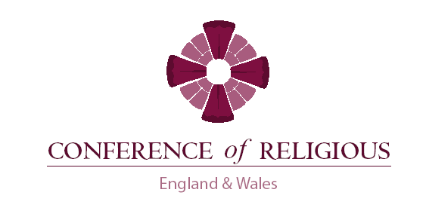

**CBCEW** **COREW**

|  |  |
| --- | --- |
| Archbishop Bernard Longley  *Archbishop of Birmingham*  Bishop Declan Lang  *Bishop of Clifton* | Fr Martin Coyle SDB  *President of COR*  Sr Mary Rose Fitzsimmons HHS  *Vice-President of COR* |
| Bishop Alan Williams  *Bishop of Brentwood*  Fr Chris Thomas  *General Secretary – CBCEW*  Lorraine Welsh  *PA to General Secretary* | Abbess Joanna Jamison OSB  *Association of British Contemplatives*  Sr Josephine Mary Miller OCBE  *Union of Monastic Superiors*  Sr Francis Orchard CJ  *COR Executive*  Br James Boner OFM Cap  *General Secretary - COR* |

**Mixed Commission**

The Mixed Commission is made up of five members from the CBCEW and five members from COR, ABC (Association of British Contemplatives) and UMS (Union of Monastic Superiors). They meet together with the general secretaries from both Conferences, managing the administrative aspects of the meetings. This enables co-ordinated discussion on significant matters within the Church, between the Religious and the bishops in England and Wales.

In its meetings it has discussed issues of common concern, including the role of Vicars for Religious, identifying religious congregations not part of the safeguarding network, the re-structuring of safeguarding commissions, the points-based system of migration, building closer links with the contemplatives, and the topics of education and healthcare; diocesan religious communities; rights and privileges of religious in a dioceses; and joint initiatives (Goddard Inquiry response) - all with a view to further developing a collaborative ‘One Church’ approach to these matters through discussion between the two Conferences. The commission is recognised as engaging the conferences in mutual dialogue with the common purpose of the Prophetic Voice of the Church being heard in England and Wales.

*“We bishops need to understand that consecrated persons are not functionaries but gifts that enrich dioceses. The involvement of religious communities in dioceses is important,” Pope Francis*

|  |  |
| --- | --- |
| https://assets.digital.cabinet-office.gov.uk/government/uploads/system/uploads/feature/image/12146/s300_UKVI__logo.jpg | http://upload.wikimedia.org/wikipedia/en/thumb/c/c8/Gov.uk_logo.svg/1280px-Gov.uk_logo.svg.png |

The Conference has continued to monitor the development of the points-bases system and its effects on the movement of Religious from overseas undertaking ministry in England and Wales. This has developed to include direct advice and ‘Level One’ administrative support by a member of the COR staff, to COR leaders applying for sponsorship.

The Conference of Religious also has a role as verifier to demonstrate that applicants for sponsorship are ‘bona fide’ Roman Catholic congregations of Religious, and sends a letter of authorisation to the Home Office to this effect, validated for each individual by the General Secretary of COR. Many Religious Congregations have been assisted by the COR Secretariat to become official sponsors. It is recognised that there is a growing trend to invite Religious from other countries to assist and enhance religious ministerial outreach. The Trustees are kept abreast of the developments in this field and seek to positively help all those requiring assistance

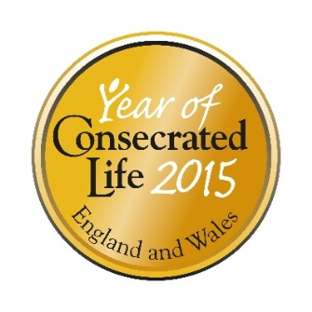

**Religious Life Promoter in the National Office for Vocation  
 sponsored by the Conference of Religious**

2015 has been a remarkable year for religious life in England and Wales. The many celebrations for the Year of Consecrated Life coupled with an unparalleled media interest in women’s religious life have helped to create remarkably fertile ground for the promotion of religious life.

A notable feature of the celebrations for the Year of Consecrated Life was the way in which different forms of consecrated life, including a wide variety of religious congregations, worked together to celebrate this special year. It was my privilege to support many of these initiatives. From the hundreds of young adults attending events in cathedrals, to smaller groups taking part in nun-runs/monastery-marathons or discussions in university chaplaincies, there were many opportunities to share the joy of religious life, as well as answering discerners’ questions and pointing them to possible next steps, such as meeting with a vocations guide or attending a discernment group.

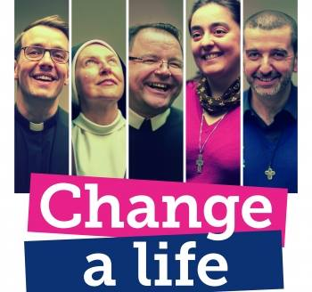As always, Vocations Sunday was a central date in the calendar of the National Office for Vocation. This year’s theme was ‘Change a Life’ and the materials, including a prayer booklet were extremely popular. We had decided to try and generate some secular media interest this year, so hired a bus-stop at which our poster would be displayed. However, just before Vocations Sunday the statistics for entrants into religious life in 2014 were released, and the media could not have been more interested in the fact that 2014 saw the highest number of women entering religious life in England and Wales for twenty-five years. There wasn’t a need for a bus stop to encourage media attention!

The media department of the Bishops' Conference analysed the widespread online coverage of this news story, and found that during April and May there were 68 online stories, with an estimated 1.91 million views and over 37,000 shares on social media. It was a great joy to see how these, along with radio and television interviews, provided many privileged opportunities to share not only why people become religious but also the core message of Christianity, Christ’s loving care for each person. Thank you to all who enabled such a positive message to be so widely shared; it was wonderful to see such a variety of religious congregations present in the media.

On a less positive note, in 2015 there were several serious hackings of the websites run by the National Office for Vocation, the latest of which necessitated a complete re-build of all the sites. Despite these challenges [www.ukreligiouslife.org](http://www.ukreligiouslife.org) continues to be very well used and discerners find the page advertising ‘Come & See’ and other vocational opportunities particularly helpful. Along with discernment groups and individual guidance, these provide often needed ‘next steps’ in discernment.

Part of my role is to advise religious and others on how to help discerners in their locality, and this has included co-ordinating training on how to lead a discernment group, as well as being part of the team training vocations guides. In 2015 training courses were held in Ampleforth and Salford, each consisting of two 48 hour sessions, with input on listening skills, discernment of spirits, the theology of vocation, youth culture and guidance for over-40s, as well as input and discussions about each state of life. More courses are planned for the future and religious superiors are encouraged to nominate people from their congregations to take part.

In 2016 I will be moving to a new community and a new mission, so I would like to take this opportunity to thank you all for your support and encouragement over the past four and a half years. It has been a joy and privilege to work with the team at the National Office for Vocation to promote a culture of vocation and to work with so many religious to promote vocations to the religious life. I ask you to extend my thanks to the religious in your congregations who are responsible for vocations ministry, without whom it would have been impossible for me to carry out my role.

**Sr Cathy Jones RA**

**Healthcare and Social Care Advisory Group**

During this year the Healthcare Reference Group changed its name and widened the scope of the committee to include Social Care. The groups new name is Health and Social Care Advisory Group (2014-2015)

The General Secretary belongs to the Healthcare Reference Group set up by the Bishops’ Conference (CBCEW), and this enables COR to be involved collaboratively with them in joint Healthcare initiatives. They organise a Healthcare Conference bi-annually on topics of interest to members. This will be held in 2016.

COR also has its own Healthcare Committee, made up of voluntary healthcare professionals at senior management levels, who advise the members of the charity on best practice in healthcare matters, and the implications of changes in legislation and regulations. This committee liaises regularly with the Catholic Bishops’ Conference of England and Wales Healthcare Reference Group (CBCEW) under the guidance of Jim McManus, Director of Public Health in Hertfordshire. The Conference works consistently to improve the Care Quality Commission’s (CQC) understanding of the nature of religious life. The CQC have now formally declared that with regards to registration, religious congregations that care for elderly members are exempt from regulations for nursing homes. This was verified by the Department of Health (DoH). Many healthcare issues which impact on the life of Religious will be addressed in a conference in 2016 which will be coordinated by the General Secretary with healthcare and legal professionals.

The Healthcare Committee remains an outstanding example of provision of guidance to members on all matters to do with health, including legal advice. The Committee draws upon the expertise of the Director of Public Health in Hertfordshire, the services of IBB Lawyers, and the voluntary support of regional matron managers. The committee keeps the Conference up to date with any change in Government Policy that affects the life and structures of religious congregations. They are involved with the Government to keep faith at the centre of the lives of those in care and in the hospital environment. They have lobbied on behalf of Religious and the church to maintain the position of chaplains in the care sector. The group meets four times per year.

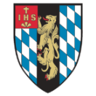  **RELIGIOUS LIFE INSTITUTE ANNUAL REPORT 2014-5** 

The Religious Life Institute [RLI] has had another successful year with continued work at congregational and national levels based on the outcomes of the Religious Life Vitality Project, funded by the Conrad N. Hilton Foundation. The main launch of the findings took place in London at the international conference, From Daughters of the Church to Citizens of the World: a Transnational Study of Catholic Sisters and the Second Vatican Council organized with the Cushwa Center for the Study of American Catholicism at Notre Dame University, USA http://cushwa.nd.edu The Vitality Project Key Findings are available online at CoR, CoRI and RLI Heythrop websites.

The Director of the RLI, Gemma Simmonds CJ, and other members of the RLI Steering Committee undertook visits to a large number of dioceses and individual congregations in the UK and Ireland to give input for the Year of Consecrated Life [YoCL]. The director has also taken this material to meetings for initial and continuous religious formation in Germany, Spain, Romania and the USA. Study days for the YoCL took place in Ireland, Wales, New Zealand (with the NZ Conference of Religious) and Spain. In June and July 2016 an adapted form of the project material will travel to India & the Philippines. At Heythrop a two-day symposium on Consecrated Life, Waking Up the World: Consecrated Life Into the Future was held with input from Timothy Radcliffe OP, Nicholas King SJ, Vivienne Keely SHF, Brendan Callaghan SJ, Helen Costigane SHCJ and Gemma Simmonds CJ. CDs are available for this and a study day with Archbishop Rino Fisichella on Religious Life and the New Evangelization. A further workshop for CoR members on the recent CICLSAL Guidelines for the Administration of the Assets from Helen Costigane SHCJ is planned this year along with study days on Scripture from Nick King SJ & Laudato Si from Prof. Celia Deane-Drummond. We would welcome your requests and suggestions for any further study days.

The Vitality Project was undertaken by the RLI, the Margaret Beaufort Institute in Cambridge and the Centre for Catholic Studies at Durham University. In November we were awarded a further grant from the Conrad N. Hilton Foundation totalling USD $985,000 over three years for two research projects supporting the vitality and sustainability of religious life in apostolic congregations of Catholic sisters in the UK, Ireland and East Africa. These projects have the added support from a robust Hilton family of grantees, such as the Union of International Superiors General in Rome and the African Sisters’ Education Collaborative [ASEC]. Our research team consists of Gemma Simmonds CJ and Catherine Sexton http://www.catherinesexton.co.uk/Catherine_Sexton/Home.html

Catherine works as a freelance consultant and is studying for a PhD at the Margaret Beaufort Institute. This second phase of research will comprise two separate projects:

• Religious Life Africa: considering the sources and nature of sustainability in women’s religious life (apostolic congregations) in East/Central Africa. This 36 month study will be implemented in partnership with a team of country/regional based partners.

• Discerning the Future: Expectations and Challenges for New Entrants to Religious Life: a 36 month project focussing on the hopes for and challenges of religious life for entrants, and those who have considered entering apostolic women’s religious life since 2000.

The Hilton Foundation are particularly keen for us to consider aspects of sustainability in women’s religious life in Africa. Such a different context requires great sensitivity of approach and therefore we requested an initial year in which to conduct a feasibility study and carry out consultation about the appropriateness of the research topic and to identify partners. A consultation will take place in Zambia in September 2016. We are equally aware of the sensitive and necessarily confidential and anonymised nature of questions to or about recent entrants to religious life, but hope that this research will provide a solid grounding from which congregations can draw up vocations and formation strategies based on factual data. We would therefore be very grateful for the cooperation of CoR members with regard to making contact with:

1. Target countries, congregations and individuals: in East/Central and possibly Southern Anglophone Africa. We are exploring work in: Zambia, Kenya, Tanzania, Uganda and Malawi.

2. Consultation in the UK/Ireland: As with the first phase of the RLVP, the research on new entrants will not be possible without your involvement and co-operation. All participation will be confidential and anonymous. We welcome your views and are willing to visit any congregation or leadership team individually to discuss this further.

**Gemma Simmonds CJ**

Director, Religious Life Institute of lifelong learning and continuing formation for religious.

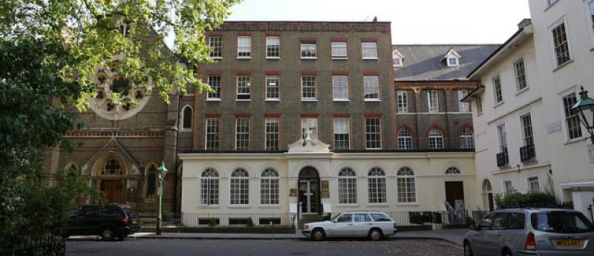

**SAFEGUARDING** 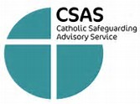

Last year’s report to the Conference said that there had been a big change of the religious personnel involved in safeguarding work on a national level: Sister Lyndsay Spendelow RSM, Sister Philomena McCluskey FMSJ and Brother James Boner OFM Cap were starting their service as members of the National Catholic Safeguarding Commission, Sister Lyndsay being the Religious Vice-Chair.

Sister Lyndsay and Sister Philomena sit on the Executive Advisory Safeguarding Group, and Brother James is its Secretary. Brother Laurence Hughes FSC has joined the Group this year; the other members are Sister Clare Smith RSM, Sister Frances Cullen CSFN, Mrs Eileen Campling, and Fr Richard Yeo OSB, the Chair of the Group. Two members who have given many years of service to Safeguarding in the Church have retired from the Advisory Safeguarding Group this year: Brother Tom Campbell FSC and Sister Daryll Candy RLR.

The current year has also seen big changes in the leadership of the two bodies which lead the Church’s work on Safeguarding: the NCSC and CSAS. The NCSC – National Catholic Safeguarding Commission -- is responsible for the strategic direction of the Church’s Safeguarding work and policy, ensuring that standards are met and policies are implemented; it has a new Chair, Chris Pearson, formerly one of the three Vice-Chairs of the NCSC, who took over as Acting Chair when Danny Sullivan retired, and was subsequently appointed Chair. CSAS – the Catholic Safeguarding Advisory Service – concentrates on advice, training, and keeping our policies up to date; Adrian Child has retired as Director, and has been replaced by Colette Limbrick. They have been as keen as we are to establish good contacts with COR and to ensure that the specific concerns and interests of religious are recognised. Both Chris and Colette have come to meetings of the Executive Advisory Safeguarding Group to discuss points of common concern.

This year has finally seen the launch of the Independent Inquiry into Child Sexual Abuse – the Goddard Inquiry. The Bishops’ Conference and COR have established a Catholic Council for the Independent Inquiry, under the chairmanship of Baroness O’Loan; members of COR will remember that she spoke at our AGM a few years ago. Religious are represented on this Council by our General Secretary, Br. James Boner OFM Cap,, Sr Lyndsay Spendelow RSM and Fr Richard Yeo OSB. The aim of this Council is to co-ordinate the Church’s work with the Inquiry, and to facilitate and ensure full and proper responses the Inquiry by the different organisations within the Church.

The last year saw two seminars on ‘Integrity and Ministry’ led by Sister Jane Bertelsen FMDM., one at Heythrop and one in Salford, which were greatly appreciated by all who took part in them. While not dealing exclusively with Safeguarding issues, ‘Integrity in Ministry’ was issued in response to the call by the Cumberlege report for COR to develop a Code of Conduct for those who work in the service of the Church.

**Richard Yeo OSB**

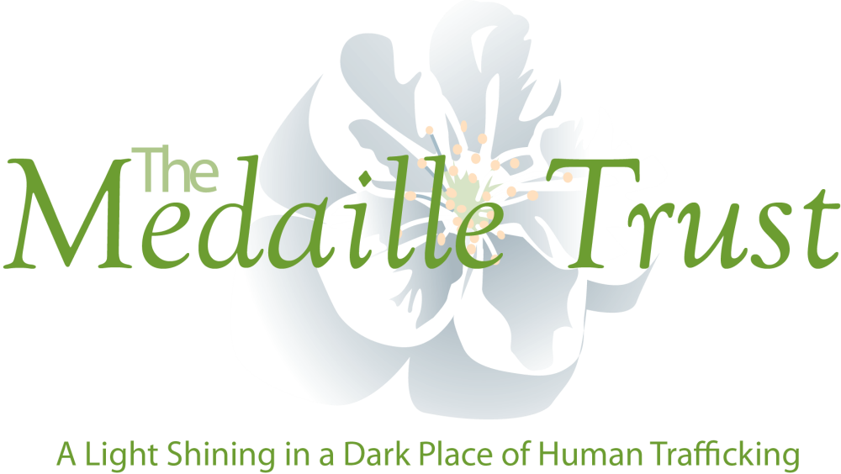

**The Medaille Trust**

**Report for the 2016 Conference of Religious (England and Wales)**

**Introduction**

This report has been prepared for COR to inform them of the work of the Medaille Trust during the financial year 2015-16 which has been a successful period for us. It comes with our sincere thanks to the Orders, Congregations and individual Religious who have been so generous in with their prayers, time, financial donations, property loans and volunteering. Without such help we could not have achieved half of we have. For this we are grateful and feel truly blessed. We acknowledge also the great work being done by Religious fellow travellers at TRAC, RENATE, Rahab, Women at the Well and others.

**Support Delivery**

The Medaille Trust continues to work in an holistic manner to deliver accommodation and support services to the victims of human trafficking and their dependants. Since the last report to the Conference of Religious the Trust has had the great fortune to be offered a further property from a Religious order at no charge. This will open on 29 March 2016 and provide 14 beds for single women. There are further plans to open two more houses but these are yet to come to fruition. One of these is a Diocesan donation. In addition we have been able to surrender a lease on one house rented from the private sector and replace it with a property on a preferential lease from a male Order.

This will bring the number of beds offered to victims by the Trust to a total of 75 as outlined below:

|  |  |  |  |  |  |
| --- | --- | --- | --- | --- | --- |
| **Service** | **Houses** | **Male** | **Female** | **Families** | **Totals** |
| ***Existing*** |  |  |  |  |  |
| Northern | 2 | 13 | 7 | 0 | 20 |
| Southern | 3 | 4 | 10 | 0 | 14 |
| Coastal | 1 | 0 | 0 | 18 | 18 |
| London | 1 | 0 | 9 | 0 | 9 |
| Central | 1 | 0 | 14 | 0 | 14 |
| Sub Totals | **8** | **17** | **40** | **18** | **75** |
| ***Proposed(2016)*** |  |  |  |  |  |
| Mersey | 1 | 9 | 0 | 0 | 9 |
| Eastern | 1 | 0 | 5 | 0 | 5 |
| Sub Totals | 2 | 9 | 5 | 0 | 14 |
| **Grand Totals** | **10** | **26** | **45** | **18** | **89** |

The model of service delivery developed by the Medaiile Trust continues to stand us in good stead and we have worked with over 200 victims during the year, with no small degree of success.

Other highlights of the period include:

* Continued liaison with our Religious partners in Kenya and Albania and the development of a further (secular) partnership in Vietnam
* Positive engagement with RENATE including training in Spain and Hungary
* The delivery of a schools pack to over 400 Catholic secondary schools
* The delivery of over 100 talks, appeals and awareness raising presentations across the UK
* The holding of a significant training event in Bled, Slovenia with some of our partners including Karitas (Croatian NGO), Different and Equal (Albanian NGO), Mary Ward Women (Albanian NGO), Salesian Sisters (Slovenian) and police officers from the Metropolitan Police, the Hampshire Police and the Warsaw Police.
* Work on resettlement and repatriation procedures including the production of a Resettlement Manual and improved links (through the Religious) with Lithuania and Hungary
* Increased participation and working with COATNET
* The appointment of a dedicated Police Liaison Officer
* The Medaille Trust has become the Co-ordinator of the Hampshire Modern Slavery Partnership (see section below)

**Impact**

The work of the Trust continues to have significant, positive impacts on the lives of the victims we are privileged to assist. The assessment process we undertake with victims is continuous and victims and staff mutually agree achievable objectives. Progress against these is closely monitored and recorded in personal files. The Trust is required, as a Government approved victim support provider, under the Home Office monitoring regime, to report *‘percentage of needs arising during assessment that are met’* and we can confirm that scores of 100% have been achieved during the period covered. We are pleased with this performance as the environment in which we operate continues to become more and more challenging as the Government introduces changes to benefits and immigration legislation that do not make our task any the easier. The recently introduced ‘right to rent’ procedures have proven particularly challenging when trying to obtain move on accommodation.

**Hampshire and Isle of Wight Modern Slavery Partnership**

The Hampshire and Isle of Wight Modern Slavery Partnership (MSP) is currently funded and supported by the Office of the Police and Crime Commissioner (OPCC). The partnership is working to coordinate a wide variety of both statutory and independent agencies’ responses to Human Trafficking and Modern Slavery. It is currently chaired by Hampshire Constabulary but includes local authority representation, the OPPC, UK Border Force, voluntary organisations and many others.

In order to work collaboratively, sharing information, identifying best practice, both locally and nationally the MSP has appointed and funded the Medaille Trust to act as Co-ordinator for the financial year 2015-16. The MSP seeks to ensure that the efforts and resources available from all agencies are utilised to the best possible effect. The MSP ensures that victims are at the heart of it’s work and keeps partner members focussed on activity to identify and provide services that provide options to support victims of modern slavery and Human Trafficking.

Hampshire and the Isle of Wight have various coastal entry and exit points and could be considered as a potential haven for exploiters. The MSP leads the coordination of a *Prepare-Protect-Pursue-Prevent* strategy to address this and the Medaille Trust ensures the MSP is fit for purpose.

The Medaille Trust also provides support to the group, expertise and a practical approach to the prepare, prevent, pursue and protect strands. It looks to the development of training tool kits to promote awareness and aid frontline professionals to identify potential victims of Human Trafficking and Modern Slavery and understand how to instigate action to support and rescue survivors.

The Medaille Trust’s main duties are to:

* Ensure a sustainable funding base from all relevant agencies
* To support and drive the MSP to achieve its main aims of; Recognition and Awareness, Communication, Victim Support, Promoting Good Practice, Prosecution, Disruption, Agency Collaboration and Sustainability –  all of these being covered by the umbrella strategy of prepare, prevent, pursue and protect.
* To facilitate integrated commissioning arrangements with Local Authorities and identify and apply to additional funding streams
* To provide a single point of contact for local agencies
* To develop the necessary products that supports the MSP and sub-groups to achieve their aims and objectives
* To ensure the MSP is aware of trends, new initiatives and best practice from around the country, including linking with other MSPs and the Home Office.
* To be responsible for all support tasks related to the MSP – agendas, minutes, liaison with agencies involved, creation of products, annual reports and reviews
* To co-ordinate and be responsible for the organisation and delivery of events in relation to the MSP, as determined and agreed by the partnership
* To sustain and strengthen the engagement of current partners with the MSP
* To ensure MSP is an integral part of the network of local voluntary organisations.
* To support discussions with neighbouring authorities and organisations to promote protection and support of victims
* To understand and comply with all relevant legislation and adhere to organisational policy, procedures and administrative procedures

The Medaille Trust is responsible to the Chair of the MSP but works with all members to improve how they tackle this criminality and support survivors.

**A Note on Costs**

The Trust’s accounts are not yet finalised for 2015/16 and until the end of year audit concludes in the next few months reliance is made, where necessary, on management accounts. However during 2015/16 the expenditure of the Trust has amounted to some £1,350,000. Of this some 8.2% is spent on management and overheads and some 7.8% on awareness raising and educational work. The monies expended amounts to an average sum of some £5,670 spent on the care of each victim, or some £94.50 per day.

**Mike Emberson - Project Director**

|  |  |
| --- | --- |
| **Message from Phil**  **McCarthy CEO CSAN** | “The Church, guided by the Gospel of mercy and by love for mankind, hears the cry for justice and intends to respond to it with all her might”.  Evangeli Gaudium p188 |

Annual Report 2015

I took up my new role as CEO at the start of December 2015 so I am conscious that the achievements of 2015 are due to the hard work and expertise of my predecessor, Helen O’Brien. I am grateful to her for the handover and support. She has built an excellent team at CSAN.

During 2015 CSAN has continued to support the network. We currently have 43 members including national and regional charities, others taking on the Caritas name for all or part of their services, and five Caritas Dioceses with several others in the ‘pipeline’. They share a Catholic ethos and a commitment to fighting poverty and to enabling people to regain control of their lives and to flourish.

Secondly we have continued to develop the advocacy and public affairs work, seeking to become an authentic voice of the Church in domestic social policy. Our aim is to influence policy makers and to get the voice of those who live in poverty and exclusion heard in the public arena. The credibility of this voice is based on the vast expertise and experience of our members.

An important part of this work was the Parliamentary Reception. This attracted a great numbers of our member organisations coming to meet their constituency MPs or other parliamentarians with interests in the welfare, housing, immigration and criminal justice. This year attendees heard a speech from our Patron, Cardinal Nichols which included an important challenge:

“The plight of refugees cannot wait. People’s generosity, in my view, far outstrips the response of our government”.

CSAN is working practically, with Secours Catholique in the camp in Calais, on advocacy with French and British MPs, and in the public arena here with NGOs and the Government. We are preparing a major Caritas document on asylum and refugee policy. This will draw on expert member insights, Catholic Social Teaching reflection, and national and international statistics and research. This aims to be a resource and guidance for the whole network.

In 2015 CSAN has worked on two major bills, made submissions to four parliamentary inquiries and one European Union consultation, provided briefings for debates and Parliamentary questions for MPs and Peers, and give detailed responses to major government announcements including the Chancellors’ Budget Statement, Autumn statement and the Queen’s Speech. A report, ‘Caritas Cares: the Impact of Welfare Changes’ drew together evidence from the network and recommendations for action.

CSAN exists to put Catholic Social Teaching into action. Looking forward the quotation from Evangeli Gaudium at the start of these remarks strikes me as the essence of what CSAN is trying to do. Pope Francis comments that this means not only small daily acts to meet the needs we encounter but also working to eliminate the structural causes of poverty. I hope that during the current Year of Mercy CSAN will do all it can to respond to the cry for justice.

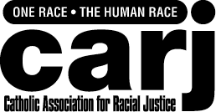

**Catholic Association for Racial Justice (CARJ)**

**Report for the Conference of Religious (COR)**

**May 2016**

Established in 1984, CARJ is a movement of grassroots Catholics working, with people from diverse backgrounds, to bring about a more just, more equal, more cooperative society. In addition to responding to issues and concerns as they arise, the following are some of our ongoing priorities:

We support young people to achieve their full potential and to live out their vocation as world citizens. We are currently developing a Stepping Stones Project to address the stubborn problem of educational inequality.

We have an Urban Network of contacts who are working for the good of marginalised communities. The Network meets three or four times a year and recently circulated a Response to the Casey Review on Integration and Cohesion

Our Travellers Support Network meets three or four times a year and includes Catholics and others who work with Gypsies, Roma and Travellers. We recently circulated a briefing on the Housing and Planning Bill, alerting parliamentarians and others to its negative impact on GRT communities.

We occasionally offer training in ‘leadership for social change’ for grassroots activists and leaders.

Due to recent changes in the annual collection for Racial Justice Sunday, CARJ is in need of personal and financial support from those who share our commitment to justice, equality and community cohesion.

**Contact**

**Gloria Oham**

**Administrator**

**CARJ**

**9 Henry Road**

**London N4 2LH**

**020 8802 8080**

**Charity number 291601**

‘

|  |  |
| --- | --- |
| JPIC Links | **Report of JPIC Links activities 2015 – 2016 – ‘To give a voice to the cry of the poor’** |

It is my burning desire that, during this Jubilee, the Christian people may reflect on the *corporal and spiritual works of mercy’* wrote Pope Francis in Misericordiae Vultus. He continues, ‘Let us rediscover these *corporal works of mercy*: to feed the hungry, give drink to the thirsty, clothe the naked, welcome the stranger, heal the sick, visit the imprisoned, and bury the dead. It will be a way to reawaken our conscience, too often grown dull in the face of poverty.’

It is inspiring to read the reports that members of JPIC Links (Justice, peace and the integrity of Creation) gave in preparation for our AGM are the living out of Pope Francis’ hopes. It is clear that members of JPIC Links) are continuing to heed the pope’s call to work in practical ways with the most marginalised groups in our society as well as engaging staff and co-workers to bring about a more just society. Newsletters, web sites, blogs and social media are all being used to spread the message and engage others in the charism of our Congregations. To highlight some activities - members are giving ongoing practical support to migrant domestic workers, asylum seekers, refugees and the homeless (visiting those in hospital, detention centres, prison etc and giving advice and help with bureaucracy, including providing education for those unable to leave home). They are involved with providing help for those in French refugee camps and are providing ongoing support for asylum seekers and refugees in England. Members visit Yarlswood detention centre and campaign for its closure while others visit the detention centres associated with Heathrow airport. We are filling in the gaps in provision for the frail elderly and handicapped (including visiting, befriending, arranging support and running drop in clubs) and working in centres for people with learning difficulties. We are working as Inter faith co-ordinators and spirituality coordinators for a variety of projects. We are active in many charities and NGO’s, including TRAC (Trafficking, raising awareness and campaigning) to end sexual trafficking, the Medaile trust, and are on the Board of RENATE (Religious in Europe networking against trafficking and exploitation). Members are active in NJPN (National Justice and Peace Network), AEFJN (Africa-Europe Faith and Justice Network), Diocesan Justice and peace commissions, Association of Senior Religious, CAFOD, Progressio and the Jesuit Refugee Service.

Pope Francis in an address to Justin Welby in 2013 said that, “Among our tasks as witnesses to the love of Christ is that of giving a voice to the cry of the poor”. As well as being involved in practical action JPIC members have continued to be involved in advocacy work.

June 2015 many of us (together with friends and associates) were part of the 9,000 strong Climate Coalition lobby of parliament when we met with 250 MPs. Since the lobby we have continued to press government for strong action to stop ‘the ecological crisis, and the large-scale destruction of biodiversity’ (Pope Francis to the United Nations General Assembly) and which ‘threatens the very existence of the human species’.

24th September 2015 many of us gathered on Millennium Bridge, London to welcome the adoption of the Sustainable Development Goals the following day. Pope Francis in his address to the United Nations called these Global Goals, ‘an important sign of hope’. We felt that shining a light on the goals was a significant ‘sign of hope.

25th September - 193 world leaders committed to 17 Global Goals to achieve 3 extraordinary things in the next 15 years. End extreme poverty. Fight inequality & injustice. Fix climate change. The Global Goals for sustainable development could get these things done - in all countries, for all people.

Saturday 26th September 30 Roman Catholic and Anglican, brothers, sisters, associates and friends met for a day conference facilitated by Dr Oonagh O’Brien (Principal of the Margaret Beaufort Institute) entitled, ‘Leave no one behind’ linking Catholic social teaching with the Global Goals for Sustainable Development.  During the day the JPIC members made a commitment to make the Global Goals widely known and committed to ‘Prayer for everyone’ to end global poverty by 2030. The more these goals are widely understood by everyone, the more politicians will take them seriously, finance them properly, refer to them frequently and make them work. As Pope Francis indicated in his address to the United Nations, ‘this is a mission for humanity, unified goals that resonate with **everyone**, everywhere’.  JPIC members have continued to make the goals known including taking part in ‘The world’s largest lesson’ (on the goals) and publishing articles in the Church Times, Independent Catholic News and Congregation newsletters.

Believing that every person on the planet wants to stand on their own feet and control their own destiny members have worked with a range of charities and NGO’s members have spoken at many parliamentary events including events on Migrant Domestic Workers, Nutrition for All, Refugees, Polio, TB and Education for All and have lobbied their MP and MEP’s. Stressing shared values and partnership in all actions they have worked to ensure that government support (in the UK and overseas) reaches the poorest and most vulnerable people.

Not forgetting the spiritual works of mercy and realising that the quality of our presence is perhaps the most important ‘work of mercy’ I quote in full from the report of one of our members who has been diagnosed with cancer:

“I see my ministry, now, as one of presence. Being present to and visiting our elderly sisters and the parishioners. Being present to the staff and patients I meet in the surgery, hospital and Hospice. I try to put into practice the words of Pope Francis. Wherever there is a Religious there should be joy - or words to that effect. So I try to listen to their stories, encourage, support and uplift them and share a laugh.”

At a time of diminishment of numbers JPIC Links values times to get together face to face to share, pray, celebrate and learn. We value the opportunities to engage with our Associates and Third Order members who come to these events. Finally we are looking forward to our Annual weekend Conference and AM at High Leigh Conference Centre 22 – 24 April 2016. This will be led by Dr Mary Grey on the topic of ‘Reconciling mercy and justice’. On October 1st we will be gathering again for our Linking Day which will be held at the parish centre of the church of Notre Dame de France, Leicester Square. Perhaps we will see you there!

**Sister Gillian Price FC April 2016**

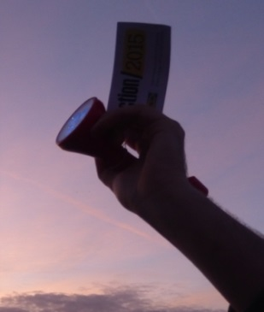 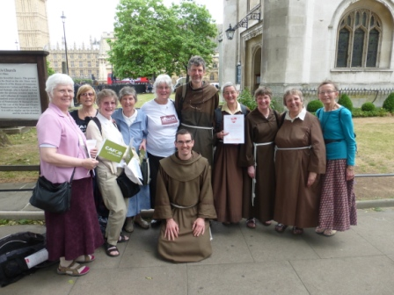

**Light Up the Way Global Change**

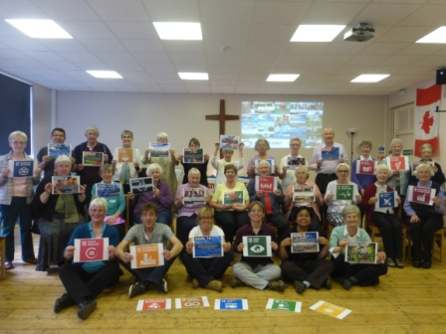 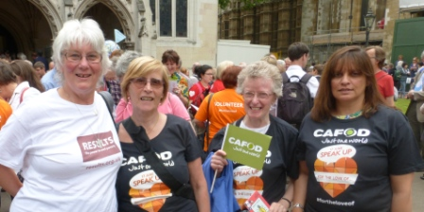

**Linking Day**



During the past year CAFOD supporters have yet again shown great generosity and compassion in support of our long-term development work. We have also responded to many emergencies, including the devastating earthquake in Nepal, the Ebola outbreak in West Africa as well as the ongoing, chronic conflict in Syria and the subsequent European refugee crisis.

Thanks to the Conference of Religious and other CAFOD supporters, we are better able to stand with our brothers and sisters across the world and help them to build more secure lives for themselves and their children. This report details just a selection of the work made possible by your support during the past year

**Emergency response updates – Syria and Nepal**

**Nepal: Helping people ‘build back safer’**

Winter in Nepal sees temperatures dropping to just above freezing. We estimate that 150,000 people are still without adequate housing for winter, so reaching them has been our greatest priority. We have been focusing on providing warm clothes, winter blankets and materials to strengthen shelters and damaged properties to withstand the cold.

CAFOD’s local partners are providing training to individuals in how to build stronger, safer houses, not only to fix their own buildings, but also to earn a living from building and improving others. Part of this training is tailored to take advantage of local materials, so that the reconstruction will also benefit local producers. We are also be embarking on a broader training programme to help farmers and craftsmen recover from the earthquakes. This will range from providing seeds and tools, to training people in new farming techniques and trades.

In partnership with Caritas Switzerland, we are working to rebuild forty schools destroyed in the district of Sindhupalchok. This was one of the districts worst affected by the earthquakes, where 89 per cent of classrooms have since been assessed as being unsafe for use if not destroyed. By getting schools up and running quickly, we can ensure that children have the space and opportunity to develop, learn and grow in safety and that their potential is not compromised or threatened by this disaster.

#### Syria: Five years on

|  |  |
| --- | --- |
| People reached inside of Syria   * **53,000 people** have received food packages * **over 22,000** people have received hygiene kits * **over 13,000** people have been supported to find safe places to live | People reached in Lebanon   * **9,000** supported to find a safe place to live * **8,049** received food * **3,850** received hygiene kits * **2,000** have received medical care. |

When the media do the roll-call of the numbers of people affected by this five year conflict; 13.5 million people are in need of humanitarian assistance inside of Syria, 6.5 million of those in need inside the country do not have a safe place to stay and millions of people are living as refugees in neighbouring countries. With such staggering statistics we must not forget that behind every single number there is a human story of loss and suffering, hope and courage.

|  |  |
| --- | --- |
| During the past five years we have been able to support our Church partners to help more than 100,000 Syrians directly, both within Syria and in neighbouring countries. Refugee families have received food, medical care, hygiene and children’s education.  Alan Thomlinson, CAFOD's Syria Crisis Manager, reflects on the crisis so far, “The grind of five years of war has exhausted everyone. The economy is in tatters, the infrastructure, electricity and water systems have been badly damaged, or completely destroyed. | © CAFOD  A family receives basic supplies |

“The school and university system struggle to educate the next generation of Syrian children and young adults, as hundreds of thousands miss out on vital years of education.”

To continue to raise the profile of the Syria crisis CAFOD in partnership the creative agency M&C Saatchi, and photographer Dario Mitidieri produced the Lost Family Portraits to highlight the impact of ongoing conflict on families. The photographs can be viewed at [www.cafod.org.uk/lostfamilyportraits](http://www.cafod.org.uk/lostfamilyportraits)

CAFOD's Syria Crisis appeal has raised more than £3 million and this year we plan on providing more food, shelter, education and healthcare to as many Syrians as we can.

**Europe Refugee Crisis**

According to the UN over one million refugees and migrants risked their lives to cross the Mediterranean Sea into Europe during 2015. More than 3,400 people died while making the dangerous sea crossing. The winter conditions have not stopped the desperate plight of people seeking safety in Europe, as the UN reports that 141,930 refugees have reached Europe by sea since the start of 2016.

As a member of Caritas Internationalis – a confederation of international Catholic aid agencies we are supporting our sister agencies who are on the frontline providing vital aid to refugees. In particular we are directly supporting Caritas Greece and Caritas Serbia, who are providing food, water, shelter, weather-proof and warm clothing and sleeping bags to thousands of refugees. In March 2016 we pledged £100,000 to Caritas Greece to support in scaling up their emergency aid response, which will also include installing basic chemical toilets and shower facilities at Idomeni. In Athens at Piraeus Port, Caritas Greece will also provide food for people who are anxiously waiting the next stage on their onward journey.

**El Salvador**

CAFOD has been working in El Salvador since 1974, inspired by Blessed Archbishop Oscar Romero, who spoke out against injustice, poverty and repression before his tragic murder in 1980 by a military assassin. Today, we focus on agriculture, reducing the risk of disasters, health and creating peace.

|  |  |
| --- | --- |
| CAFOD’s partner CONTRASIDA, founded by Sister-Doctor Mary Annel, works with both women and men to educate communities about gender-based violence and HIV.  The project encourages them to reflect on their social roles, using radio. They also run workshops, helping young men to explore and question some male stereotypes that encourage unhealthy behaviour and showing the benefits of more equal relationships between men and women. | Men in El Salvador standing up for equal right between women and men. © CAFOD  “Domestic work is also work.” |

**Democratic Republic of Congo**

It’s a three hour, 30km, four wheel drive journey from Goma in Eastern DRC to the village of Rukwi. Access to this village is poor as it is on an extremely bad road. However, this is where our local partner Caritas Goma has just completed a water treatment unit.

The water treatment unit ensures soil and debris do not flow through the pipes to the nearby water storage tank. From the tank, piping has been laid to six water stand posts, four in the village itself, and one each in the local school and health centre.

This water system has changed the lives of the local women and girls in particular. ‘Before, we took two hours each day to collect water,’ said 37-year-old Musabirema Mariya. ‘Women and children walked to the spring, two kilometres away, up and down a steep slope. Now, water is on our doorstep.’

There are many health benefits of being able to wash cooking utensils properly and give clean water to their children to drink, reducing diarrhoeal diseases. The women in this community were particularly pleased to be able to wash their clothes and send their children to school washed and ready to learn. The women are now able to look forward. Muhoza Yvonne, who is 30 years old, has a burning desire to establish a women’s association in the village, to support vocational training and income generating activities.

The story of the women in Rukwi highlights that **water is not only necessary for survival, but for dignity**. It is this which will open so many more doors for this community.”

**Cambodia**

In the provinces of Ratanakiri and Mondulkiri in Cambodia, indigenous communities often do not have access to adequate water and sanitation. Alongside our partner Development and Partnership in Action, we are working with 26 indigenous communities to find new ways of managing water resources with technical support from specialists.

|  |  |
| --- | --- |
| In the past year alongside this work we have been supporting women’s leadership in the community, giving women more confidence and skills to engage in community discussions, particularly about water. Women are particularly affected by water shortages, as they often fetch water and use water for their crops it is vital that they have a say.  During the past year we have worked with the 26 indigenous communities to create long term solutions to water scarcity. | A new way of cucumber farming that increases yield and requires less water. © Samban Seng/CAFOD  Cucumber farming that requires less water in Ratanakiri |

**Campaigns update**

Much of our campaigning and advocacy work during the past 12 months has focused on climate change and its impact on poorest communities. On 17 June 2015 over 9,000 people, including CAFOD supporters from every diocese, met their MPs in the biggest ever climate lobby of Parliament to express their concerns about climate change and its devastating impact on people living in poverty overseas.

Last year, an incredible 40,000 supporters signed our climate petition calling on David Cameron to show leadership at the UN climate talks in Paris. At the talks, nearly 200 countries agreed a historic climate deal. The Paris deal sends a signal to business and investors that we have started the shift to a low carbon economy. I t is a start towards limiting global temperature rise below 2 degrees and to pursue efforts to keep it below 1.5 degrees.

In a letter to CAFOD, Climate and Energy Secretary Amber Rudd recognised the importance of this agreement as a “clear turning point towards a sustainable and low carbon future”. She also highlighted the important role that Pope Francis’ encyclical *Laudato Si’* played in securing an ambitious deal on climate: “I would like to thank CAFOD for the key role they played in helping to communicate the document and look forward to working closely together to build on what was achieved at COP21.”

**Lent 2016**

Once again CAFOD’s Lent Appeal has been matched by the UK Government, up to a limit of £3.5m – potentially doubling the impact of all our supporter donations. CAFOD is committed to helping the most disadvantaged and hardest to reach people living in poverty. One of the most significant challenges is access to water for drylands in Uganda, the Democratic Republic of Congo and Zimbabwe.

|  |  |
| --- | --- |
| Our Lent appeal is focusing on improving access to safe drinking water and promote safe hygiene and sanitation practices to over 340,000 vulnerable women, men and children living in DRC, Uganda and Zimbabwe.  To date we have raised over £2.7million! | ***UK-AID-Donations&flag-RGB*** |

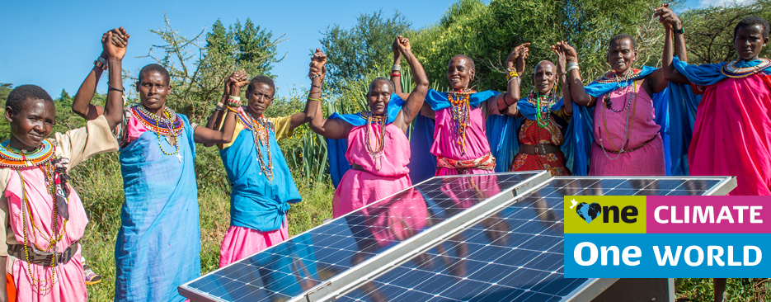

|  |  |
| --- | --- |
| HJ | **2015/16 Report for Conference of Religious** |

This year homelessness has continued to increase. The number of people counted sleeping rough in England in the Government snapshot figure for November 2015 was 3,569, an increase of 30% from the same figure in 2014. At the end of December 2015 there were 69,140 homeless households in Local Authority provided temporary accommodation, including 106,140 children. This was 12% more than the same date in 2014 and there is no sign that either of these figures will go down during 2016.

In 2016 we are marking the 60th anniversary of the founding of the Catholic Housing Aid Society. Maisie Ward was a writer, theologian and the daughter of a prominent Catholic publisher. Molly Walsh and her husband, Bob, ran a House of Hospitality during the depression. Molly and Maisie met through the Catholic Evidence Guild. They shared a concern about the needs of young families in Britain after the war. Especially as they saw the damage done to children who were being brought up in dreadful slum conditions and the lasting impact on family life. Molly and Maisie joined forces to persuade the Catholic Church to respond to the needs of people who were homeless or living in poverty – a witness of the Catholic community to the problem, but a service to the entire community. In 2003, when CHAS merged with the Churches National Housing Coalition, Housing Justice picked up this baton. Our aim remains that everyone should have a home that truly meets their needs and that Christians play their part in bringing this about. We remain extremely grateful for the donations and especially the prayer support of religious orders for our work – without this our task would be so much more difficult.

Sixty years on Housing Justice, as the successor organisation to CHAS, continues to work to meet a need that is tragically, just as great today. Throughout this year we will have a renewed emphasis on persuading the churches to rise to the challenge of preventing homelessness and helping homeless people into secure, genuinely affordable accommodation. As an ecumenical organisation we will be issuing the same challenge to all the churches in England and Wales – and to parishes, schools and individual Christians.

There will a number of events marking this diamond jubilee but we are particularly asking local groups, parishes and schools to hold a Housing Justice event to reflect on the current situation and commit to taking action to make a difference. And to start the year off well we have a special prayer written by our Chair of Trustees, the Bishop of Rochester, and a prayer card with the CHAS Jubilee prayer and an invocation to St Benedict Joseph Labre, the patron saint of homeless people. We are also carrying on the tradition of not waiting for the Government to sort out a problem but instead taking the action we can to make things better. And not being afraid to use our prophetic voice to speak truth to power about the impact of Government policies.

**Church and Community Night Shelters**

Over the winter 2014-15, around 500 Churches, Church Halls, Synagogues and Mosques opened their premises for use as night shelters providing hospitality and support between October 2014 and May 2015. 2,171 guests were accommodated and an estimated 231,000 volunteer hours given to be alongside them through 70,000 separate volunteering attendances. During the year we helped new shelters open up and assessed others for the Housing Justice Quality Mark. We provided a holiday break for shelter guests and volunteers at the Scargill Community in Yorkshire and brought shelter coordinators together in regular forums in London and the South East and in Wales.

**Mentoring and Befriending Project**

Our own Mentoring and Befriending project wound up at the end of the year. However, we are still providing a tool kit on our website for other organisations to set up their own programme of mentoring and befriending people who are making the difficult transition from homelessness to housed. We regularly provide volunteer training and support to new programmes like this around the country.

**Faith in Affordable Housing**

Our FiAH team are currently working with churches, housing associations and local authorities across England and Wales. We have a new England Coordinator, Jackie Cottingham, and a case worker based in Cumbria, Judith Derbyshire. We are always looking for new sites and are able to provide support and guidance from the first considerations through to the completion of the building and new residents moving in. Please do get in touch if you think we can be of assistance.

**Migrant Destitution**

In response to the signs (and needs) of the times, and utilising some of the expertise of our team freed up by the ending of our mentoring and befriending project, we have opened up a new area of work. Nationally we are a member of the Strategic Alliance on Migrant Destitution which brings together homelessness and refugee and migrant agencies with the aim of increasing the amount of accommodation, advice and humanitarian aid for destitute migrants who are already in the UK. An important part of this work is the development of London Hosting, a scheme to match hosts with spare rooms with destitute migrant guests who need accommodation in the Greater London area.

**Homeless Sunday**

Homeless Sunday 2016 was on 24th January. Unfortunately, this clashed with Racial Justice Sunday because the Bishops’ Conference Liturgy Office moved around some of the special Sundays in the year but did not announce the changes until all our materials were prepared. In 2017 Homeless Sunday will be on 22nd January. So far as we know this does not clash with any other special Sunday. We are always pleased to receive prayers and reflections which can be incorporated into the resources for the day, so please send any contributions to a.gelder@housingjustice.org.uk.

**Events**

We held Roadshows in Manchester, Exeter, London and Preston. We launched the CHAS Diamond Jubilee celebrations with a reception in the House of Lords in April 2016. We continue support regular prayer and action forums for Christians involved in homelessness work in London and Birmingham, as well co-organising the annual service of commemoration for people who have died homeless at St Martin in the Fields in November. Our London Christian Homelessness Forum now meets twice termly, alternating between late mornings in our office and evenings at Mount St Jesuit Centre. For more information please check our website: www.housingjustice.org.uk or email info@housingjsutcie.org.uk

**Advocacy**

We have briefed Catholic Parliamentarians and Anglican Bishops as the Housing and Planning Bill is making its way parliament. Further information from a.gelder@housingjustice.org.uk, or on our website: www.housingjustice.org.uk, or call 020 3544 8094. **For more information please check our website:** [www.housingjustice.org.uk](http://www.housingjustice.org.uk) **or email** [info@housingjsutcie.org.uk](mailto:info@housingjsutcie.org.uk)**.**

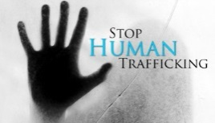 **Report on Trafficking in Europe.**

Trafficking in human beings remains one of the most lucrative businesses in the world. Currently there is a reported 21 million people in slavery or trapped in slave-like conditions. There is a massive need to end this kind of slavery and the trafficking of men, women and children for sexual purposes their labour or their organs.

Renate (Religious in Europe Networking Against Trafficking and Exploitation) and TRAC (Trafficking, Raising Awareness and Campaigning) believe that by putting an end to “DEMAND” it will stop the supply of cheap labour, sex-for-sale and the sale of organs in the world.

Everyone is entitled to live in a world where love, justice and equality is a human right. We must fight against the notion that this is too big for us to change. For that reason both Renate and TRAC believe that the way to do this is to implement what is known as the “Nordic Model”. So called because it became law in Sweden first then, Iceland and Norway and now has spread to Canada and Northern Ireland as well as France just recently. This law is also before the Scottish Parliament and was before the Irish Parliament before the recent election. Hopefully when a Government is formed in Ireland this law will be passed.

The “Nordic Model” begins by decriminalizing the women who are in prostitution and criminalizing the men who buy them. It also means giving the women an alternative lifestyle. Most women in prostitution are there because of poverty, a drug habit or because they have been trafficked. It is not enough to take away poor peoples’ means of making money without giving them the chance to have another way of life.

TRAC will soon be beginning to campaign to roll out the Nordic Model in England and Wales. To do this we need to have a major lobby of Parliament. We are fortunate in this country that we have a democratic process where we know who our Member of Parliament is and how to contact them. We have begun to seek alliances in Parliament and we will soon be embarking on a series of talks wherever we can and will be sending out a sample letter for people to send to their MPs.

**Marie Power HFB**

|  |  |
| --- | --- |
|  | **2015 Annual Report from the Catholic Missionary Union of England & Wales** |

**Liaison with the bishops**

One of the primary purposes of the CMU is to act as a liaison between the missionary community in England & Wales and the bishops. With them, we have been actively involved in the Missionary Endeavour review and the work to update the guidelines and criteria for mission appeals in parishes

**Leadership and strategic Planning**

Thanks go to Fr Tom O Reilly who as Regional of the Columbans stepped in to the role of CMU President during 2015 replacing Fr Rob Morland SMA who had been CMU President for two full terms. At the AGM in 2015 Fr Terry Donnelly CSSp and Fr Martin Devenish MCCJ were elected as President and Vice President respectively.

**Giving value to the members**

The CMU has almost 40 members drawn from a range of organisations ranging from the congregations founded for overseas mission to others which have taken up a strong presence in particular overseas countries. We are also including in our membership lay missionary groups and the ‘new’ missionaries from global South who are present here.

In 2016 two ‘Working Groups’ are being developed – one on education and one on the missionary vocation. The education Working Group will oversee a pilot project called ‘meet a missionary’ to provide input to young people.

**Organisational development**

In 2015 we started, and will complete this year, a review of the CMU’s Statutes putting us on a good footing for the future. Our three committees : Sisters’, Men’s and Combined – continue to meet and support each other

Yours sincerely in Christ, Fr. Terry Donnelly CSSp, President Mr Richard Owens, Secretary

**ASSOCIATION OF BRITISH CONTEMPLATIVES 2016**

2015, the Year of Consecrated Life, we found an enriching and dynamic experience. A new spirit of openness and co-operation seemed to be moving among us, arising from the joy from the publications of the Holy Father and also those of CICLSAL. At the invitation of the Congregation, the ABC received substantial encouragement to attend the Symposium for Religious in Rome early this year. One of our Executives represented us and rejoiced in the experience. Apart from a lot of walking, one of the abiding memories was the willingness of Archbishop Carballo and Fr. Paciolla to make themselves available to the participants, and to explain some of the workings of the Congregation to them. Hats off to the Congregation for wrestling with the logistics to make everything work so well.

Since then, there has been a great deal of formal and informal sharing of experiences, perceptions and summaries of lectures. The latest publication from the Holy Father, *Contemplate,* is the icing on the cake.

One consequence of this flurry of activity is that, reluctantly, we have cancelled the meeting we had scheduled for the end of June. The Executive felt there was a bit of meeting fatigue, and that we had had a wealth of material to digest already this year, within our own groups. Next year will be a more profitable time for a bigger gathering and sharing.

One other activity we have undertaken this year is to initiate a professional assessment of the archives of the Economics Commission and the work of Sr. Kate Coombes, mainly in the latter half of the 20th century. These archives contain a wonderful record of the work done for the contemplative communities and also provide an interesting glimpse into the social and religious realities of the times.

We wish you a very successful and fruitful meeting, and reiterate our gratitude for the companionship and support of the members of CoR. United in prayer

*Sr. Mary of the Holy Spirit ODC (Chairperson ABC)*

|  |  |
| --- | --- |
|  | **Conference of Religious of Ireland (CORI)** |

CORI Activities 2015-2016

Since our AGM in June last year, much of the activity in which CORI was involved centred around the celebrations for the Year of Consecrated Life. One of the main projects was “Prayer in the City” : an undertaking to celebrate Evening Prayer in a city centre church (Clarendon Street, off Grafton Street), each Thursday evening at 6 pm, beginning at the opening of the YCL and continuing until the close of the year in February 2016. The idea was that each prayer would be prepared by a different congregation, who would also use the opportunity to introduce their congregation and say something about their particular spirituality and apostolates. Forty-two different congregations and groups took part in what proved to be very informative, prayerful, celebratory gatherings, helped along by the hospitality of the Carmelite community in Clarendon Street.

To name but a few of the other events: there was a very enjoyable pilgrimage walk of about 11 kilometres to St Finbarr’s shrine in Gougaune Barra, Co. Cork, along back roads and over the mountains – not for the faint-hearted! The local bishop, John Buckley, met us in the small church on the island at the end of the walk and we celebrated Mass together. The was also a pilgrimage to Knock, and open day for religious and their families in the Cistercian Abbey, Roscrea, and a highly successful conference day with input by Gemma Simmonds and in which they fed back the outcome of the Religious Life Project in which some Irish congregations were involved and which led to very lively discussion. There were also many events organised locally in dioceses and parishes countrywide.

Overall the experience of the year was very positive: it was a time of prayer. Of togetherness and sharing, of celebrating who we are quite apart from what we do, of rediscovering the richness of our calling and recovering some bit of confidence after the battering of recent years. All over the country, groups came together to reflect and pray and we are grateful for the many ways in which the Local Churches expressed their appreciation of the value of religious life in general and, in particular, of the religious living in their midst.

Otherwise the main focus was on trying to create a new entity with IMU. It has been a very long drawn out process and is not over yet. But we continue our discussions and hope to have a definite proposal for our members before our AGM in early June.

Changes in the Healthcare and Educational fields are ongoing and have involved CORI members in consultations and discussions with the relevant statutory bodies.

**Peter Rodgers OFM Cap**

Director General

CORI



**Report from the Conference of Religious in Scotland March 2016**

Since the last report to the Conference of Religious in England and Wales in March 2015, the Conference of Religious in Scotland have organised four events - Spring Conference, AGM and two events for the Year of Consecrated Life.

The Spring Conference was held on 9th May 2015 in Glasgow. The keynote speakers were Fr Tony Byrne CSSp and Sr Kathleen Maguire PBVM whose inputs were on the theme:

‘Recognising the Gifts of Senior Religious’.

Fr Tony emphasised that Religious Congregation are for all ages and should enable older members to fulfil the great potential that they have based on their experience of living a long life. Sr Kathleen focussed on everyone’s need to have a sense of worth and of being appreciated. Senior religious still need this, even those in failing health as this does not diminish their humanity or worth. Both inputs were very well received and very relevant to the lives of many of those present. There was ample time for discussion and pertinent questions from the seventy or so religious present.

About sixty Religious attended the AGM in Edinburgh on Saturday 17th October 2015 in Sacred Heart Church Hall, Lauriston. In a very lively and animated presentation, Fr. Eamonn Mulcahy CSSp spoke on the topic of:

‘Revolution of Tenderness and Mercy,

The Role of Religious in Pope Francis’ Vision of Church’

Fr. Mulcahy, gave some pointers to the direction Pope Francis' papacy is taking – the theme of mercy which Pope Francis not only talks about but puts into practice, his call to religious to ‘be prophetic’, his concern for the marginalised.

The afternoon session was devoted to the AGM business meeting. A vacancy on the Executive was filled by Sr Veronica Kealey, Sister of Nazareth.

The first of the two events for the Year of Consecrated Life was a Day of Prayer on 24th June 2015. All the Religious in Scotland were invited to come to the National Shrine of Our Lady of Lourdes at Carfin in Motherwell Diocese. In the morning there was a led Reflection followed by Mass and in the afternoon an hour of Eucharistic Adoration followed by Evening Prayer. About seventy religious took part in this day and fortunately the weather was relatively kind with the rain holding off until late afternoon.

To mark the conclusion of the Year of Consecrated Life a celebration was held in Glasgow for all the religious in Scotland. On 2nd February 2016, Mass was celebrated St Andrew’s Cathedral with Archbishop Philip Tartaglia, Archbishop of Glasgow, the main celebrant. He was joined by three other Scottish Bishops and a number of priests from religious orders. At the start of Mass all the religious present processed into the Cathedral carrying lighted candles, a most impressive sight due to the large number who attended. During Mass the Religious renewed their vows and their commitment to serve the Church in Scotland. After Mass everyone moved across to nearby Eyre Hall to enjoy a delicious and generous buffet. In all about two hundred religious from across Scotland braved the ferocity of Storm Henry to attend this event.



**AMDG**

**MARYFIELD CONVENT, ROEHAMPTON, SW15 4JA**

**UISG REPORT - COREW AGM 2016**

**1967 - GOLDEN JUBILEE - 2017**

**The Jubilee will be celebrated at the Assembly in Rome at an audience with Pope Francis.**

The International Union of Superiors General is an international forum where general superiors of Catholic women’s religious institutes can share experiences, exchange information and accompany each other in carrying out their service. The UISG promotes dialogue and collaboration among religious congregations in the Church and society. Today, after 50 years of existence, the UISG, is formed by 1,858 General Superiors, leaders both of pontifical Institutes and diocesan Institutes present in more than 100 countries and representing more than 470,000 women religious.

As an international organism rooted in Christ and representing the Religious Congregations for women in the world, the UISG seeks to witness and proclaim the identity of apostolic religious life in all its diversity.

Weaving global solidarity and opening new frontiers, we animate, support and encourage Congregation Leaders to be a voice and prophetic witness in the Church and in the world. The mission of the UISG is that of building bridges that shorten distances, boundaries and frontiers to give the members the possibility of communicating among themselves, creating community and living in communion. Its aim is that of making the meaning of religious life understood.

UISG in the UK has a membership of approximately 25 Superiors General who currently meet three times a year to discuss issues of common interest and to provide mutual support for members. Meetings take place in March, July and October and are held at St. Philomena’s Convent, Euston Square. We appreciate the support of Tim Rutherford, Stone King Solicitors and Amanda Francis, Buzzacot Chartered Accountants who keep us updated on relevant issues of importance.

Plenary meetings take place in Rome every three years with an attendance of up to 950 women leaders. The next meeting takes place in Rome from 9th – 13th May 2016 with the wonderful title of **Weaving Global Solidarity for Life *– ‘That they may have life to the full’***. The Strategic Plan which the Executive Members have been working on for the past year will be presented to the membership.

[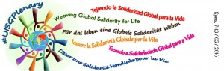](http://www.internationalunionsuperiorsgeneral.org/meetings/assembly/)

The Union is divided into a number of Constellations. The UK belongs to one of two Northern European Constellations. Other countries in our English-speaking Constellation are Norway, Ireland, Netherlands and Malta. The Constellation meets once in the three year cycle and the UK will be hosting the next meeting in April 2017.

I would recommend membership of the UISG to any Congregation Leader as it is a very positive means of support in the fulfilling of one’s role as Superior General.

**UISG Initiatives - internationally:**

* Solidarity with South Sudan – an inter-congregational project.
* Talitha Kum is an Anti-trafficking project of UISG which co-ordinates, at international level, networks of women religious.
* UISG and USG collaborate in different commissions.

If you would like further information on membership of UISG please contact me on email: [mary.whelan@psmgs.org.uk](mailto:mary.whelan@psmgs.org.uk) or telephone 0208 788 4351

**Mary Whelan SMG**

**UK Delegate**

**Association of Provincial Bursars**

The Association, which provides support and Networking for Bursars of Religious Orders and their Teams, has had another busy year. Membership continues to grow and widen, with an increasing number of lay Bursars being involved as well as professional firms who are “Friends” of the Association.

Compliance with legislation from the Charity Commission, Public Benefit and Financial Requirements, Governance & Trusteeship, Health & Safety, Employment Law & Managing Investments continue to dominate our work. Increasingly, as many Religious Institutes reduce numerically (at least in the northern hemisphere) more questions are being raised by members about the implications of merging Provinces on the charitable status of their assets within the United Kingdom.

The Annual conference, held (as usual) at High Leigh during the first week in October, attracted great support from the membership and attendance by other members of Trustee bodies and professional firms. We are already in advanced planning stages for this year’s conference from 3rd to 6th October and hope to see many of our friends from COREW there.

The new Executive was elected at the AGM and details of those now serving can be found on our web site: [www.apbursars.org.uk](http://www.apbursars.org.uk)

**Michael Barwick (General Secretary)**

**THE ASSOCIATION OF SENIOR RELIGIOUS**

**2015 – 2016**

The Association of Senior Religious had one hundred and twenty communities from all over Britain subscribing for the current year. Each community receives a copy of the Summer and the Winter Newsletters published by the National Executive. The Newsletter is contributed to by the membership and is the main organ of communication and support between the Members, and between the Members and the National Executive.

In March 2016, one hundred Religious attended the three-day ASR National Conference held as usual in Bournemouth. Our Speaker this year was Fr. Nicholas King S.J. who, in this Jubilee Year of Mercy, gave us outstanding talks on “The God of Mercy”. The conference was subtitled “Living at a Tangent”, taking up Pope Francis’ claim that ‘it must be possible to live differently in this world’. Many Sisters commented that it was the best conference ever!

We were delighted that for about a third of those attending the conference it was their first time which bodes well for the future of the Association. As older members find they can no longer travel, younger members are becoming involved.

At the AGM, Sr. Sheila Sumner OSM was elected as National Treasurer in the place of Sr. Antonia Doyle RSM who has finished her term of office. Sr. Mary Cannon,

(Sion), was elected as Deputy Secretary in the place of Sr. Ann McNally (Sion) who has also completed her term.

The Association would very much like to resume the close links we had with the Council of Religious in earlier years.

**Sister Hazel Buckley FMDM**

**ASR National President**

**Conference of Leaders of Anglican Religious Communities (CLARC)**

The Conference of the Leaders of Anglican Religious Communities met at the community of the Resurrection, Mirfield in October 2015.

The main speakers - Rev. Richard Coles - an Anglican Priest, presenter of BBC 4 programme Saturday Live and a relentless social/mainstream media user. Revd. Frankie Ward, Dean of St. Edmundsbury Cathedral and author of ‘Rouseau was wrong: Christianity and the secular society’; and Ben Vickers, leader of ‘unMonastery’ in London a community organisation, a place-based social innovation combining monastic traditions with hackerspace ethos spoke as a panel. The discussion which aimed at exploring the lives, language and technology used by young people exploring vocations was challenging and very informative.

The Community of St. Anselm was inaugurated under the Leadership of Archbishop Justin at Lambeth in September, Formation and day-to-day responsibility for the Community is in the hands of a group of members of the Chemin Neuf Community. The regular programme of daily worship is enhanced by an exciting range of experiences of different aspects of monastic life. During their one year community experience the members have had the chance of spending a week or two sharing the life of traditional Religious Communities and also of taking a 30 day IGR with the Chemin Neuf in Switzerland. The members share in the work of local charities in ministering to those in various kinds of need. All members testify to it being a life-enhancing and life-changing period of discernment for them. The first intake completes its period in July and a new ‘community’ will arrive in September.

More work has been done to standardise the manner of Episcopal Visitations and a Paper was produced. A policy for Religious Communities regarding safeguarding has been adopted by the House of Bishops and is now available on the Church of England website with an implementation plan. Communities are encouraged to ensure that their current policy complies with the newly approved national policy.

A small group of Leaders have been meeting at Lambeth Palace to examine critically and realistically the state of Religious Life with the aim of recovering a sense of purpose and hope.

A working party was set up to give thought to the way the vow of Obedience is understood and presented to those enquiring about Religious Life. The working party gathered and collated information to produce a new article on the vow of Obedience which is now on the Religious Life website. The current internoviciate programme is working well and is proving successful and popular and will continue in the same format.

The new requirements of the Charity Commission for completing a risk register for returns in the future were received.

Many Communities are experiencing an increase in the numbers of people seeking to be associated with them as Associates or Oblates. Their increased involvement in the life of the Community is being explored by many Communities as a way of maintaining the future of the Community with fewer vowed members.

**UNION OF THE EUROPEAN CONFERENCES OF MAJOR SUPERIORS**

|  |  |
| --- | --- |
| logo1 | **UCESM**, a Church association of Canonical Right and also an International Non-Profit-Making Association of Belgian Right (AISBL), is a union at the service of Religious Life in Europe. For the time being (March 2016), UCESM gathers **39**national Conferences of **28** European countries for a total of about 240.000 religious men and women.  membership to the video library. |

**ACTIVITIES IN 2015**

***Meetings at which members of the Committee / members of the General Secretary took part***

*(reports/proceedings were sent to all the Conferences in due course)*

***On 23rd to 27th February 2015,*** Sr Viviana Ballarin op, Vice-President, was delegated by the Executive Committee to participate in the international meeting of vocation ministers and religious leaders from English-speaking countries, organized in Rome by the National Religious Vocation Conference (NRVC) in the United States. The purpose of this meeting was three-fold: learn about the larger vocation picture beyond one’s own country; identify common areas of convergence in needs for vocation promotion and awareness; explore future areas for collaboration in promoting new membership to religious life.

***On 23rd-28th March 2015,*** the 16th General Assembly of UCESM took place in Tirana, Albania. Its topic was: “*Religious Men and Women in Europe: Witnesses and Shapers of Communion*”.

***On 19th May 2015***, Sr. Josyane Cluzel sdc was delegated by the EC to represent UCESM at the General Assembly of COREB (French-speaking Conference of Belgium) in Ciney (Belgium). This meeting gathered more than one hundred Major Superiors and delegates for reflecting on the topic: “*Live one’s vows at the borders”.* Sr. Josyane took the opportunity of this meeting to convey to the Belgian religious leaders the urgent need for UCESM to find a new Secretary General as from September 2015 (as Sr. Josyane had been entrusted a new mission by her congregation by that time).

***On 3rd June 2015***, Sr. Josyane Cluzel represented the UCESM-Board at the Forum “*Education today and tomorrow*” organised in Paris under the patronage of UNESCO by the Permanent Observer of the Holy See to UNESCO and the Prefect of the Congregation for Catholic Education.

***On 18th-21st June 2015,*** UCESM-President Fr. Giovanni Peragine crsp attended the Congress of CLAR (Latin-American Conference of Religious) in Bogotá, Colombia, which was put under the topic: “*We listen to God where life cries out*”. The Congress fitted into the framework of the Year of Consecrated Life. The Prefect of CICLSAL, Cardinal João Braz de Aviz, made a presentation. The various interventions were an incentive to all the members of consecrated life to reaffirm their commitment to look at the new horizons and the liveliness of their charisms today.

***On 6th-9th July 2015,*** Sr. Ivanka Mihaljevic ssf, UCESM-councillor, attended the European Vocations Congress in Prague (Czech Republic) on behalf of the UCESM-Board. Its theme was: “*How to guide young people to priesthood and consecrated life in the family today*”. This annual meeting sponsored by the Commission for Priestly Vocations of the CCEE focused on the comparison of the different vocational realities in the countries of the various experts invited, the sharing of hardships and obstacles and the suggestion of criteria and guidelines for the vocational service.

***On 2nd-4th September 2015,*** the secretary-translator at the UCESM-headquarters in Brussels was commissioned by the Board to represent UCESM at the annual International Congress of Renovabis (the Solidarity action of the German Catholics with Eastern Europe) in Freising (near Munich). That year’s theme “Eastern European Youth – Future prospects?” aimed at examining the outlook of young people on life and faith, also in prospect of the World Youth Day in Cracow at the end of July 2016.

**SISTERS MISSION COMMITTEE**

**REPORT FOR THE YEAR ENDING DECEMBER 2015**

The committee is composed of major superiors or representatives of the Institutes of Religious Sisters having many members overseas, especially in developing countries. We have two members on the executive of the Catholic Missionary Union: Sr Margo Murphy, RNDM and Sr Assumpta Giertych SSPC. Those of us who attend meetings of any groups of interest to our work in the promotion of mission continue to report appropriately to the committee.

In 2015 fifteen societies of missionary sisters gave the annual mission appeals in parishes in the dioceses of Birmingham, East Anglia, Hallam, Nottingham and Plymouth as allocated to us by arrangement with the bishops. The appeals enable us to raise awareness of the importance of “mission” and the need for all baptised Christians to be in mission as members of the world wide as well as of the local church. We see mission as our responsibility to work for the establishment of God’s reign in our world and to take the good news of Jesus to all who either have not heard it or have not seen it as relevant to them. Mission is clearly not only “overseas” but here at home also. In the parishes visited we offer ideas of ways in which parishioners can be involved in mission themselves in their own parish. Examples are: concern for lonely and sick people, advocacy on behalf of marginalised people, ethical investments, using our purchasing power to challenge unjust structures by raising questions with suppliers and buying fairly traded goods. We also use our experience of the Church in other parts of the world to highlight needs in those areas and give ideas of how people can promote change. In 2015 we continued to emphasise the need to cancel unjust debt and to oppose emissions causing climate change. In 2015 a number of us attended various justice campaign rallies and meetings.

The mission appeals are an important source of funding for us since we have traditionally worked mostly overseas with people who are very poor and therefore cannot support us. In our appeal for funds we all work together, combining the money raised and sharing it out at the end of the year according to the number of appeals given by each congregation. In this way it makes no difference whether we visit large or small parishes, or even if the collection does not cover our costs if the parish is very small. We are happy to have the privilege of sharing our first-hand experience of the Church in different parts of the world.

The committee met twice this year to look together at issues encountered in our overseas work or in our work here, but we are also in contact with each other via email.

**Rose Mary Harbinson, RNDM (chair)**



A little bit of mercy makes the

world less cold and more just.

(Pope Francis)